**Course Name: Analog Communication**

**MATLAB Experiment-5**

**Objective**: Design two low pass filters with transfer function, $H_{1}\left(s\right)=\frac{1}{s+1}$ i.e. linear phase and $H_{2}\left(s\right)=\frac{1}{s^{2}+s+1}$, i.e. non-linear phase. Find the response of the multi-tone signal

$x\left(t\right)=0.5*\cos\left(2*π*10*t\right)+\cos\left(2*π*20*t\right)-0.2*\cos{(2}*$ π $*30*t)$

for two filters. Draw the amplitude, phase spectra of the filters, and compare them. Also, comment to the obtained results.

**MATLAB Code:**

t=0:0.001:10; % time scale

k=0:1:10000; % samples of fft

x=0.5*cos(2*pi*10*t)+cos(2*pi*20*t)-0.2*cos(2*pi*30*t); % input with some phase & frequency

h(t>=0)=exp(-t); % impulse response of linear filter

h1(t>=0)=(2/1.732)*exp(-0.5*t).*sin(1.732*0.5*t); % impulse response of non-linear filter

H=fft(h); % 10001 samples of Fourier transform of linear filter

H1=fft(h1); % 10001 samples of Fourier transform of non-linear filter

X=fft(x); % Fourier transform of input

Y=H.*X; % frequency response of linear filter

Y1=H1.*X; % frequency response of non-linear filter

y=ifft(Y); % time domain response of linear filter

y1=ifft(Y1); % time domain response of non-linear filter

subplot(321)

plot(t,x)

xlabel('time(sec)');

ylabel('x(t)');

legend('Input Signal')

subplot(322)

plot(t,0.001*y)

xlabel('time(sec)');

ylabel('y(t)');

legend('Filtered Response Linear Filter')

title('Linear Filter')

subplot(323)

plot(t,0.001*y1)

xlabel('time(sec)');

ylabel('y(t)');

legend('Filtered Response Non-Linear Filter')

title('Non-Linear Filter')

subplot(324)

plot(k,0.001*abs(H),k,0.001*abs(H1))

xlabel('frequency(Hz)');

ylabel('Magnitude Response');

legend('Linear Filter','Non-Linear Filter')

title('Magnitude Response')

subplot(325)

plot(k,angle(H),k,angle(H1))

xlabel('frequency(Hz)');

ylabel('Phase Response');

legend('Linear Filter','Non-Linear Filter')

title('Phase Response');

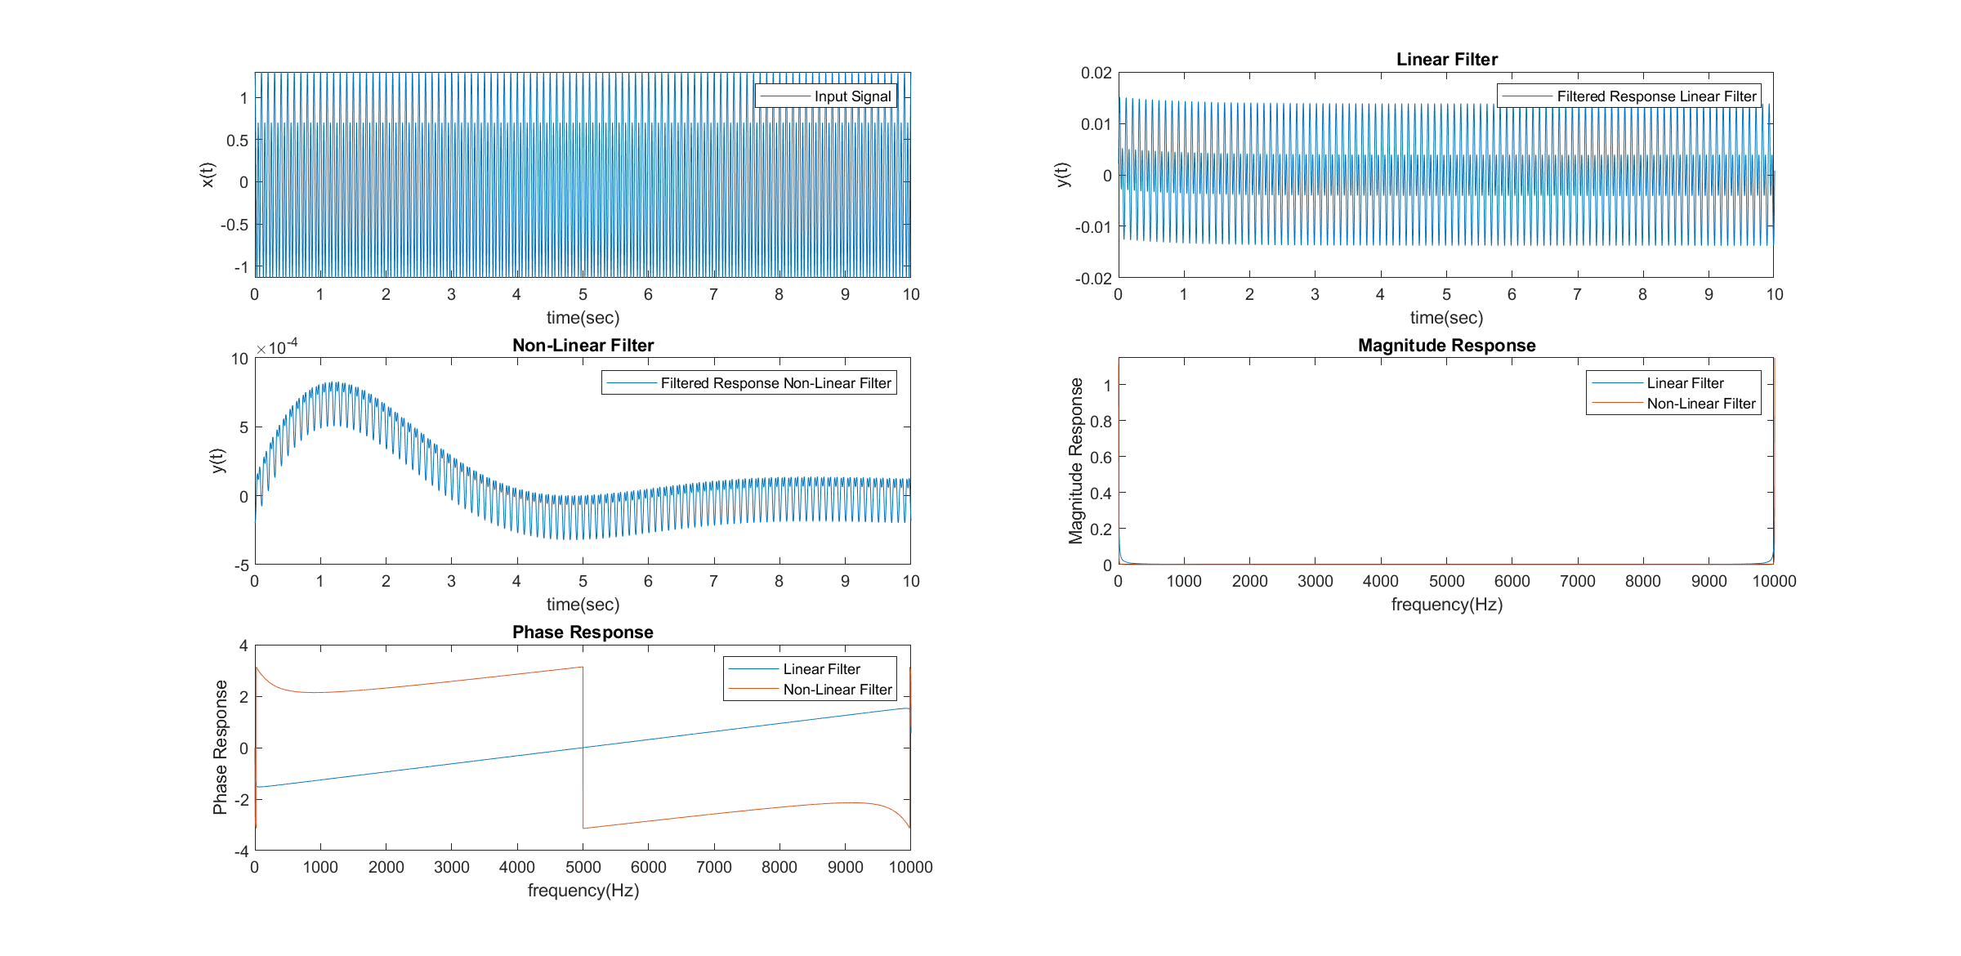**Result:**